#
# 20180609
# There was a task SD#1400653.
# In the task it’s need to create user account on two CommuniGate servers and write access to these two CommuniGate servers from defined several hosts.

#
# I’ve tried to make ssh tunnel under my MobaXterm utility - but was not worked at all.
#
# Everything below was made in my Virtualbox Centos virtual host.
#

# To make ssh tunnle we neen root access to target server. To make access as a root I’ve copyed my ssh key (open part of it) on to target server.
#
[support@centos 20180525-1714]$ ssh-copy-id -i ~/.ssh/id_rsa.pub bsv@prtmail01.tcsbank.ru
The authenticity of host 'prtmail01.tcsbank.ru (192.168.5.174)' can't be established.
RSA key fingerprint is cb:18:11:33:3c:99:79:f2:1a:22:71:a6:7e:7f:af:63.
Are you sure you want to continue connecting (yes/no)? yes
/usr/bin/ssh-copy-id: INFO: attempting to log in with the new key(s), to filter out any that are already installed
/usr/bin/ssh-copy-id: INFO: 1 key(s) remain to be installed -- if you are prompted now it is to install the new keys
bsv@prtmail01.tcsbank.ru's password:

Number of key(s) added: 1

Now try logging into the machine, with: "ssh 'bsv@prtmail01.tcsbank.ru'"
and check to make sure that only the key(s) you wanted were added.

[support@centos 20180525-1714]$

# Then I’ve connected to target server, get root permissions and copy my ssh key to root account.
[root@vm-prt-dmz-mail01 ~]# cp ~bsv/.ssh/authorized_keys ~/.ssh/
cp: overwrite `/root/.ssh/authorized_keys'? y
[root@vm-prt-dmz-mail01 ~]# ls -Alh ~/.ssh/
total 8.0K
-rw------- 1 root root 1.1K Jun 9 12:39 authorized_keys
-rw-r--r-- 1 root root 391 Jun 9 11:42 known_hosts
[root@vm-prt-dmz-mail01 ~]#

# Here I’ve made tunnel from remote target server port 9010 to local port 9010.
# Remote part of command.
# Local par of command.
[support@centos 20180525-1714]$ ssh -L 127.0.0.1:9010:127.0.0.1:9010 root@prtmail01.tcsbank.ru
Last login: Sat Jun 9 12:29:03 2018 from 172.16.28.74
[root@vm-prt-dmz-mail01 ~]#

# How looks result of command on my local virtualbox host.
[root@centos yum.repos.d]# ps axu | grep ssh
root 1138 0.0 0.0 82468 1264 ? Ss May25 0:00 /usr/sbin/sshd
support 2772 0.0 0.0 52864 568 ? Ss May25 0:03 /usr/bin/ssh-agent /bin/sh -c exec -l /bin/bash -c "/usr/bin/startkde"
support 6874 0.0 0.1 80340 4284 pts/3 S+ 12:39 0:00 ssh -L 127.0.0.1:9010:127.0.0.1:9010 root@prtmail01.tcsbank.ru
root 6935 0.0 0.0 112648 960 pts/2 R+ 12:40 0:00 grep --color=auto ssh
[root@centos yum.repos.d]#

# In follow file I can see CommuniGate web-interface user “postmaster” password.
[root@vm-prt-dmz-mail01 ~]# cat /var/CommuniGate/Accounts/postmaster.macnt/account.settings
{
Password = postmaster;
UseAppPassword = YES;
WebAdminPrefs = {DisplayCharset=utf-8;ExpertLevel=10;ServerSettings={};};
}
[root@vm-prt-dmz-mail01 ~]#

# Next step we connect to our localhost port 9010, that was redirected to remotehost port 9010.
# When I’ve tried to open web-page in Firefox web-browser, I’ve received follow error about ssl certificate. I couldn’t fix it.
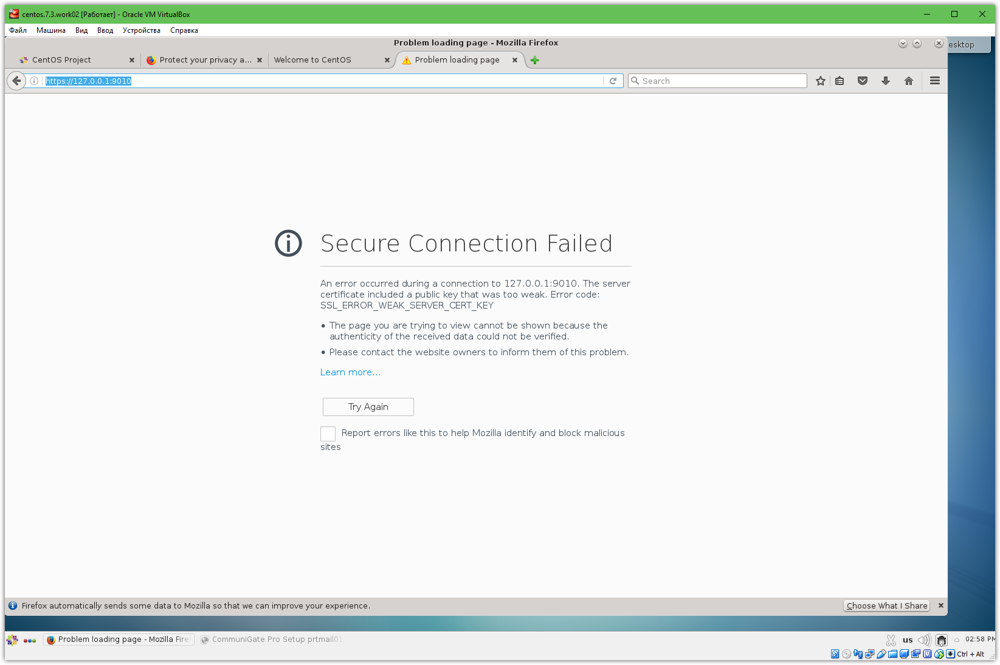

# I’ve used to this local browser.
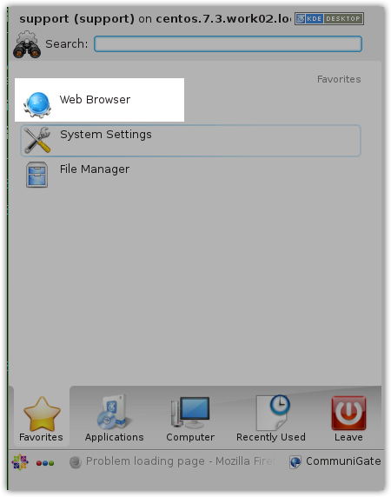

# I’ve opened follow link.
# https://127.0.0.1:9010
# Then enter login and password.
# And then start to create user.
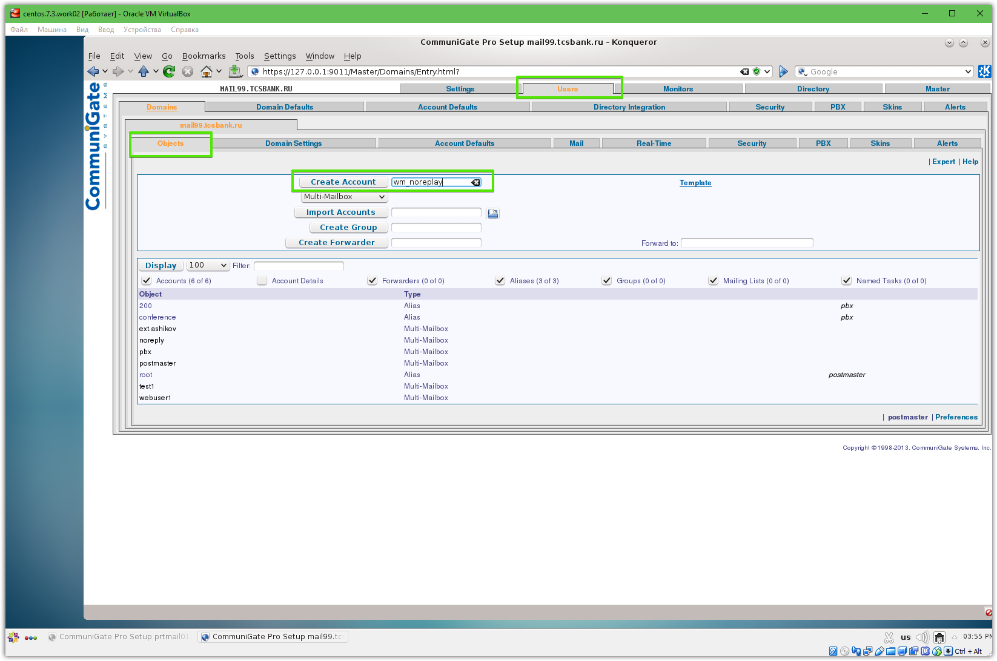
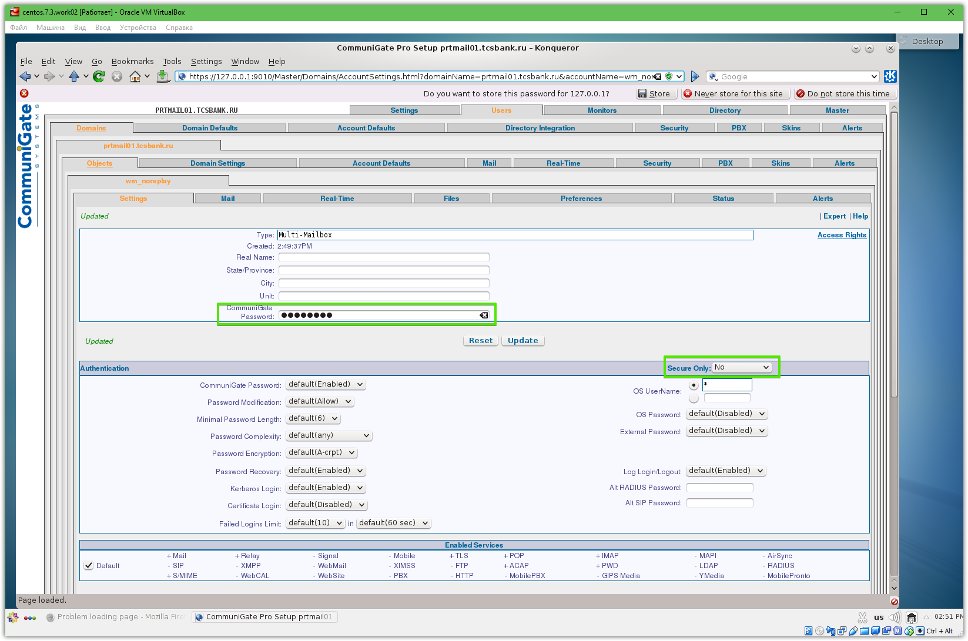

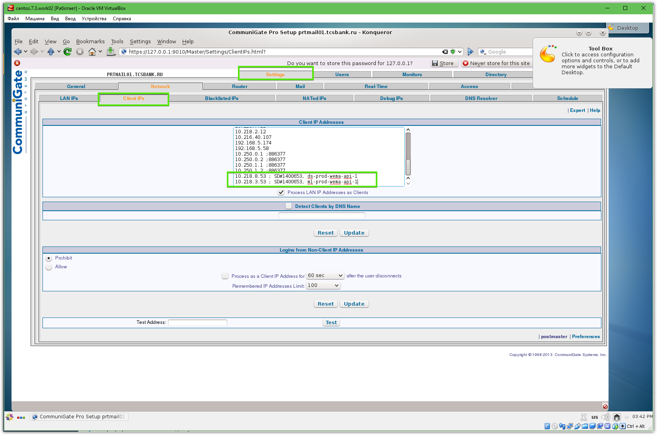
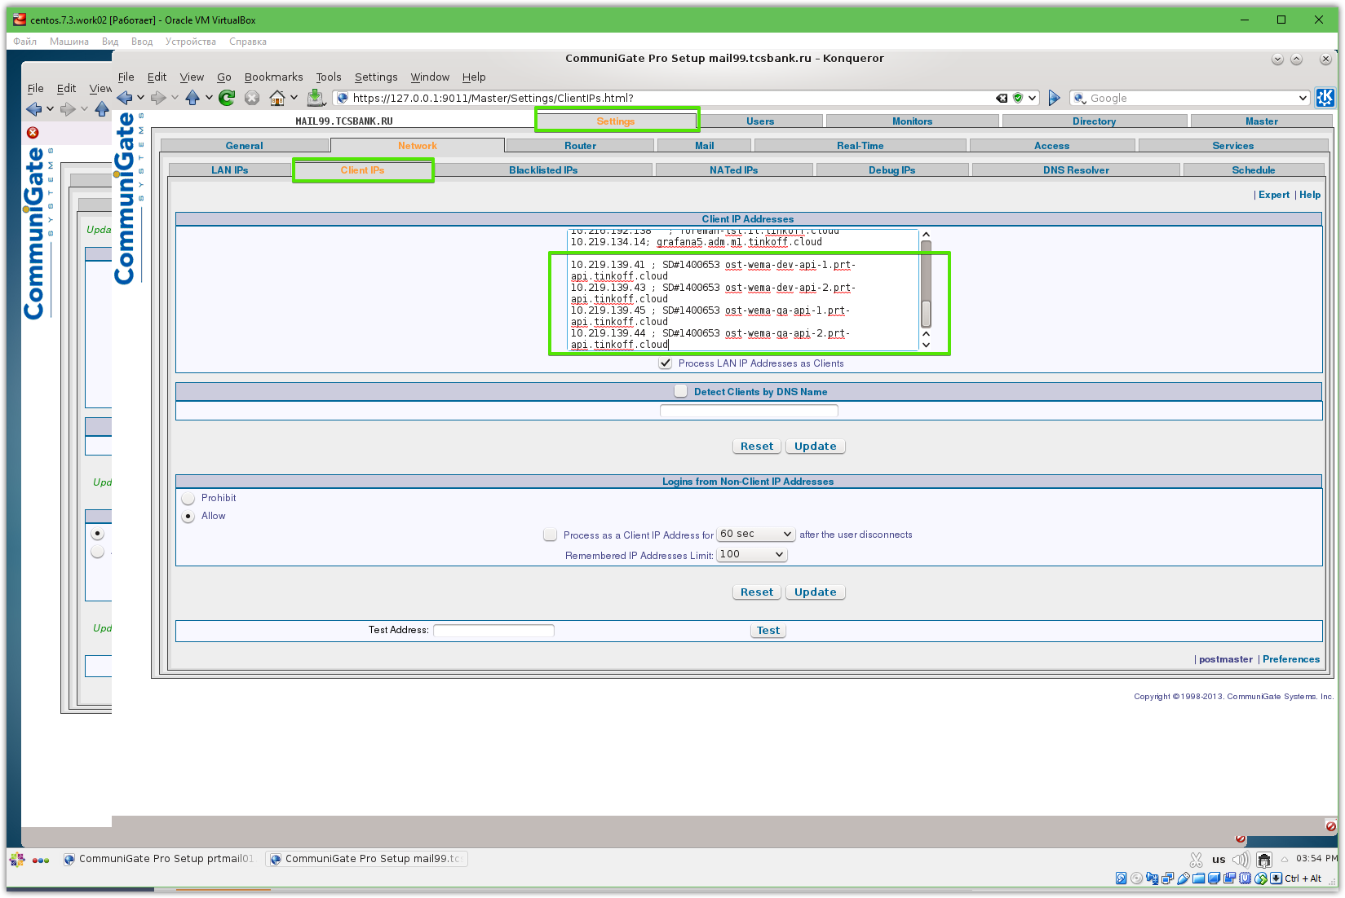

#
# Then I did same for the second CommuniGate server.
# Only local port I’ve changed to other: 9011 to avoid conflict with already busy by previous redirection.
#
[support@centos ~]$ ssh-copy-id -i ~/.ssh/id_rsa.pub bsv@mail99.tcsbank.ru
/usr/bin/ssh-copy-id: INFO: attempting to log in with the new key(s), to filter out any that are already installed
/usr/bin/ssh-copy-id: INFO: 1 key(s) remain to be installed -- if you are prompted now it is to install the new keys
bsv@mail99.tcsbank.ru's password:

Number of key(s) added: 1

Now try logging into the machine, with: "ssh 'bsv@mail99.tcsbank.ru'"
and check to make sure that only the key(s) you wanted were added.

[s.belogrud@TCS4357]# ssh bsv@mail99.tcsbank.ru
Warning: Permanently added 'mail99.tcsbank.ru' (ECDSA) to the list of known hosts.
bsv@mail99.tcsbank.ru's password:
Last login: Sat Jun 9 15:43:45 2018 from 172.16.28.74
[bsv@vm-test-app99 ~]$ sudo -i
[sudo] password for bsv:
[root@vm-test-app99 ~]# ssh localhost
The authenticity of host 'localhost (::1)' can't be established.
ECDSA key fingerprint is a5:32:19:b5:4a:67:9c:80:20:9e:96:00:7d:6a:63:36.
Are you sure you want to continue connecting (yes/no)? no
Host key verification failed.
[root@vm-test-app99 ~]# ls -Alh ~/.ssh/
total 0
[root@vm-test-app99 ~]# cp ~bsv/.ssh/authorized_keys ~/.ssh/
[root@vm-test-app99 ~]# logout
[bsv@vm-test-app99 ~]$ logout
Connection to mail99.tcsbank.ru closed.
[s.belogrud@TCS4357]#

[support@centos ~]$ ssh -L 127.0.0.1:9011:127.0.0.1:9010 root@mail99.tcsbank.ru
Last login: Fri Nov 13 18:41:05 2015 from tcs6365.tcsbank.ru
[root@vm-test-app99 ~]#

https://www.communigate.com/communigatepro/HelpMe.html

...
I have deleted the Postmaster account
If you have deleted the postmaster account, stop the Server and start it again.
If the CommuniGate Pro Server does not find the postmaster account during the startup process, it creates a new one. Check the postmaster account files to get the new postmaster password, in the same way you used when you installed the CommuniGate Pro Server.
....

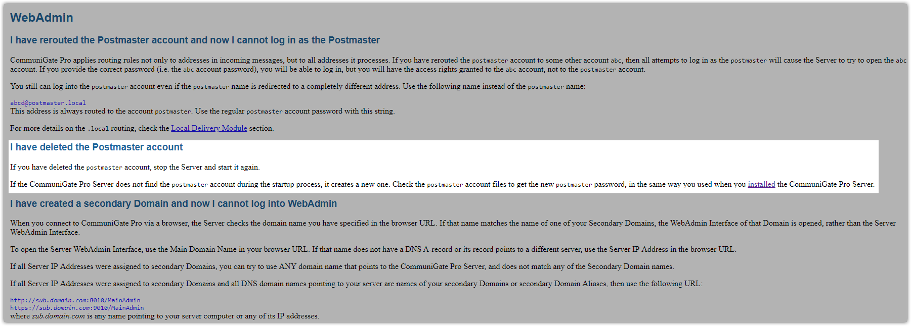

https://www.communigate.com/communigatepro/Install.html#Config

